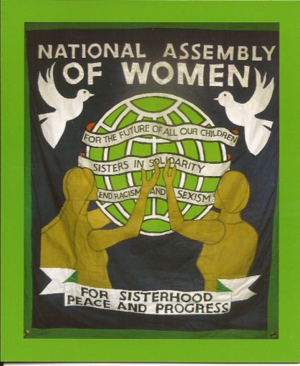**THE NATIONAL ASSEMBLY OF WOMEN *campaigns for:***

◻ *Full employment opportunities for women*

◻ *A living wage and an end to the gender pay gap*

◻ *A trade union bill that ensures employment rights*

◻ *A state pension that ensures pensioners live in dignity*

◻ *A free, comprehensive and secular education system*

◻ *Full access to education, training and work for women*

◻ *A publicly owned and fully funded NHS*

◻ *Improved maternity benefits and affordable child care*

◻ *Access to free reproductive health services and abortion*

◻ *A legal framework and financial support to end domestic and other forms of violence against women*

◻ *An end to gender stereotyping and bias in the media*

◻ *No restriction on civil liberties or human rights as set out in the Human Rights Act 1998*

◻ *A safe, affordable, publicly owned transport system*

◻ *Decent housing at reasonable cost*

◻ *The provision of good local services*

◻ *The development of environmentally sustainable and renewable energy sources*

◻ *Development of alternative forms of domestic and industrial waste disposal*

◻ *Linking with women’s organisations worldwide to assist in the campaign for equality and peace*

◻ *An end to the arms industry and the economic dependency on military manufacturing*

◻ *Respect for a nation’s right to self-determination and sovereignty*

**The National Assembly of Women supports**

Abortion Rights, Charter for Women,

The People’s Assembly Against Austerity

National Pensioners’ Convention, End Child Poverty Campaign

Campaign Against the Arms Trade, Campaign for Nuclear Disarmament, Cuba Solidarity Campaign, Palestine Solidarity Campaign,

Sylvia Pankhurst Memorial Committee

And has shares in the Morning Star and Wortley Hall

THE NATIONAL ASSEMBLY OF WOMEN

72 Beaconsfield Road,

Coventry CV2 4AR

www.sisters.org.uk

naw@sisters.org.uk

07939 948404

**The National Assembly of Women** was founded on the 8th March 1952 at St Pancras Town Hall, London. Women from all walks of life and from all parts of Britain came together to pledge their support for the aims set out in the International Charter for Women for the defence of peace, for higher living standards and the rights of children to health, education and a full life.

 The National Assembly of Women continues to campaign for the full social, economic, legal, political and cultural independence and equality for women regardless of age, race, colour, religion, philosophical belief, sexual orientation or nationality.

 It is well supported by the labour and trade union movement and is proud to have a number of outstanding women as honorary Vice Presidents.

 As the only British women’s organisation affiliated to the Women’s International Democratic Federation (WIDF), it remains committed to

international solidarity and supports the struggle for women’s rights throughout the world.

***President*** *Liz Payne;* ***Secretary*** *Sandra Durkin;*

***Treasurer*** *Carolyn Simpson*

***Vice Presidents*** *Vera Baird KC; Rita Donaghy CBE; Helena Kennedy KC;*

*Gloria Mills CBE; Sarah Woolley*

***JOIN THE NAW***

***Annual membership fee £20*** *(£10 unwaged)*

*Renewable each January*

***Annual affiliation fee for organisations:***

***£20*** *(NAW branch or local group)*

***£60*** *(national organisation)* ***£45*** *(regional)*

***Cheques payable to the National Assembly of Women and send to:***

***The Treasurer, Carolyn Simpson, 26 Birchanger Road, London SE25 5BB***

I would like to join the NAW and enclose a cheque for £20 (£10 unwaged) which includes my subscription to SISTERS, the journal of the NAW.

**Our organisation would like to affiliate to the NAW. Enclosed is a cheque:**

*£20 (NAW branch or local group); £60 (national organisation) £45 (regional)*

Name________________________________________________________

Address______________________________________________________

_____________________________________________________________

_____________________________________________________________

Email address_______________________________________________________

Phone________________________________________________________

Organisation___________________________________________________

_____________________________________________________________

We only use your personal details to send information related to your membership of the NAW. We never pass any personal information to other individuals or organisations.

**Standing Order Form**

To make a regular contribution and to save having to remember to renew your membership to the **NAW** please fill in this form and return to the NAW Treasurer: ***Carolyn Simpson, c/o 26 Birchanger Road, London SE25 5BB***

To (your bank) ___________________________________________

Branch & Address________________________________________

_______________________________________________________

_______________________________________________________

Your sort code___________________________________________

Your Account Number_____________________________________

Please pay on receipt of this order the sum of £__________

(minimum £2 per month) and on the same day each month thereafter

**OR**

Please pay on receipt of this order the sum of £__________

(minimum £10/20 per year) on the 1st January of each year thereafter

To: Unity Trust Bank, 9, Brindley Place, Birmingham B1 2HB

Sort code 60-83-01

To the credit of the National Assembly of Women

Account Number 20364894

This mandate replaces any previous standing order to the National Assembly of Women

Name__________________________________________________

Signed_________________________________________________

Date___________________________________________________